**RDBMS**

Relational Database Management System

Where the records are stored in Tabular or relational form

**We use some terms in RDBMS**

Relation > Table> Collection of all Records

Attribute / Field / Column > Characterstics Features which describe an entity

Here rn, name , address , marks

Record / Tuple / Row > Collection of data for one entity

|  |  |  |  |
| --- | --- | --- | --- |
| Rn | Name | Address | Marks |
| 1 | Ajay | Delhi | 90 |
| 2 | Deepak | Gurgaon | 98 |
| 3 | Prabhas | Delhi | 78 |

Degree of a Relation > No. of columns in a table **4 –nary**

**1-nary / Unary relation , where table has only 1 column**

**2-nary / Binary relation , where table has only 2 columns**

**3-nary / Ternary relation , where table has only 3 column**

**Cardinality of a Relation > No of Records > 3**

**We follow some Integrity Rules**

1. **Entity Integrity > That we should be able to identity all entities uniquely , To achieve this, we use PRIMARY KEY**

**PRIMARY KEY > It is used to uniquely identify all the records**

1. **Unique / No duplicacy**
2. **It can not be null**

**In this case , Rn is the primary key**

**2.Referential Integrity > We are talking about more than 1 table**

**We achieve this integrity by using Foreign Key**

**Foreign Key > It is a column whose value is dependent upon value of primary key of some other table**

**It could be either null or value has to be from primary key of some other table**

**Student(Here rn is the primary key)**

|  |  |  |  |
| --- | --- | --- | --- |
| **Rn** | Name | Address | Marks |
| 1 | Ajay | Delhi | 90 |
| 2 | Deepak | Gurgaon | 98 |
| 200 | Prabhas | Delhi | 78 |

**Fee table (Here rn is the foreign key, it is linked to rn of student table)**

|  |  |
| --- | --- |
| **Rn** | **Fees Paid** |
| **3** | **9000** |
|  | **3000** |
|  |  |

1. **Domain Integrity > Values of columns could be entered from a set or pool of values**

**For Marks column, domain is 0 – 100**

**For rn column, domain is 1 – 200**

**For address column, domain is Delhi , Gurgaon**

**Sql Server (Server where SQL is installed)**

**SSMS : Sql Server Management Studio (Tool by using which we can work with Sql Server)**

**We need a language to work with RDBMS**

**Sql > Structured Query Language**

**Its is the language by which we interact with RDBMS (Sql Server)**

**To work with Sql Server, open SSMS**

**It will ask you to connect to Sql Server**

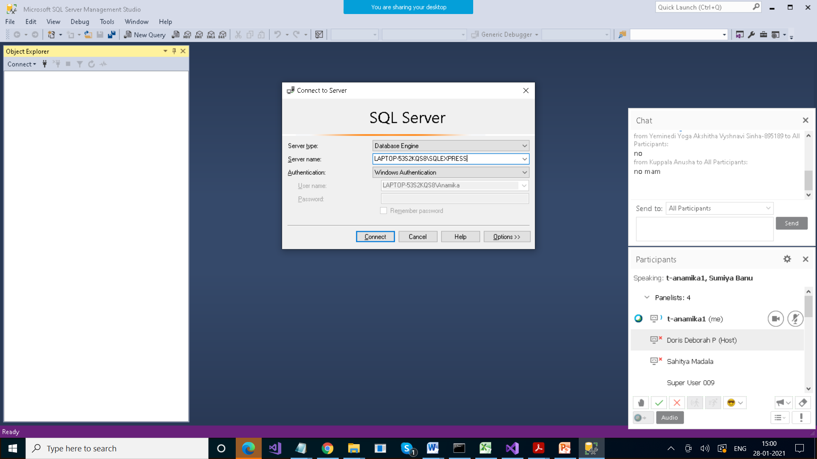

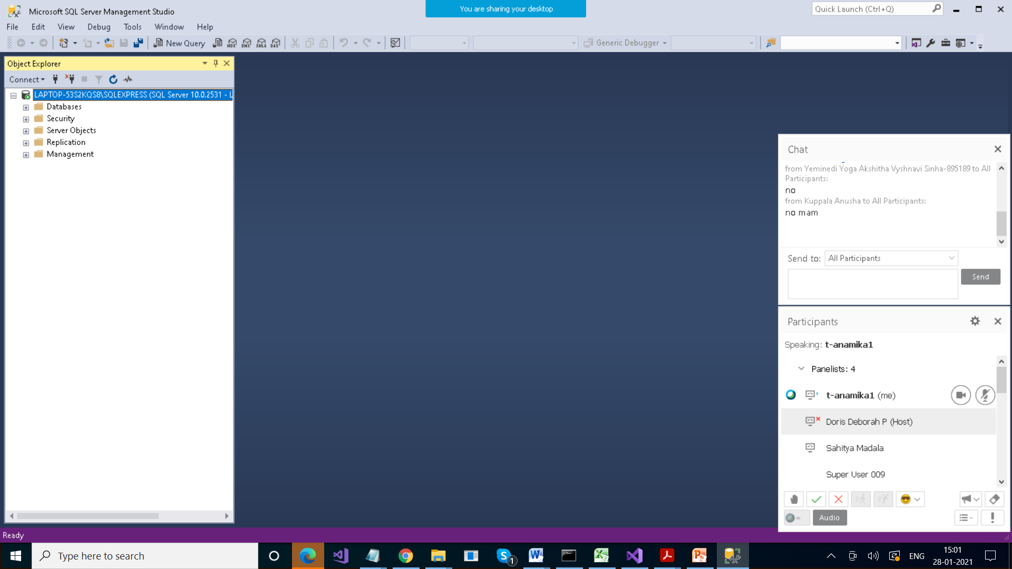

Sql > It’s a language that we use to work with RDBMS

Features of Sql

1. Case insensitive
2. Easy to understand because it contains statements like simple eng word

Statements in SQL are of following types

1. DDL > Data Definition Language

Create , alter , drop , truncate table

1. DML > Data Manipulation Language

Insert , delete , update , select

1. DQL > Data Query Language > select
2. DCL > Data Control Language

Grant , revoke

1. TCL > Transaction Control Language

Commit , rollback

DDL >